### **1. Users Table**

|  |  |  |  |
| --- | --- | --- | --- |
| **Attribute Name** | **Data Type** | **Description** | **Example** |
| user_id | INT (PK) | Unique identifier for each user | 101 |
| full_name | VARCHAR(255) | User’s full name | John Doe |
| email | VARCHAR(255) | User’s email address | [johndoe@email.com](mailto:johndoe@email.com) |
| password | VARCHAR(255) | Hashed password for security | ******** |
| user_type | ENUM('Customer', 'Admin') | Specifies if the user is a customer or admin | Customer |
| created_at | TIMESTAMP | Date and time when the user registered | 2025-03-14 10:00:00 |

### **2. Consultations Table**

|  |  |  |  |
| --- | --- | --- | --- |
| **Attribute Name** | **Data Type** | **Description** | **Example** |
| consultation_id | INT (PK) | Unique identifier for consultation | 5001 |
| user_id | INT (FK) | References the user booking the consultation | 101 |
| service_type | ENUM('Solar Panel Installation', 'EV Charger Setup', 'Smart Home Consultation') | Type of consultation booked | Solar Panel Installation |
| consultation_date | DATETIME | Date & time of the consultation | 2025-04-10 14:00:00 |
| status | ENUM('Pending', 'Confirmed', 'Completed', 'Cancelled') | Status of the consultation | Confirmed |

### **3. Energy Products Table**

|  |  |  |  |
| --- | --- | --- | --- |
| **Attribute Name** | **Data Type** | **Description** | **Example** |
| product_id | INT (PK) | Unique identifier for energy product | 3001 |
| product_name | VARCHAR(255) | Name of the product | Solar Panel Kit |
| category | ENUM('Solar', 'EV Charger', 'Smart Home') | Type of product | Solar |
| price | DECIMAL(10,2) | Cost of the product | 2999.99 |
| stock | INT | Number of units available | 50 |

### **4. Carbon Footprint Table**

|  |  |  |  |
| --- | --- | --- | --- |
| **Attribute Name** | **Data Type** | **Description** | **Example** |
| footprint_id | INT (PK) | Unique identifier for carbon footprint entry | 7001 |
| user_id | INT (FK) | References the user tracking footprint | 101 |
| monthly_energy_usage_kWh | FLOAT | Total energy consumption in kilowatt-hours | 1200.5 |
| carbon_output_kg | FLOAT | Calculated CO₂ emissions generated | 320.7 |
| recorded_date | TIMESTAMP | Date the footprint was logged | 2025-03-14 |

### **5. Carbon Footprint Calculations Table**

|  |  |  |  |
| --- | --- | --- | --- |
| **Attribute Name** | **Data Type** | **Description** | **Example** |
| calc_id | INT (PK) | Unique identifier for calculation entry | 9001 |
| user_id | INT (FK) | References the user performing the calculation | 101 |
| transport_emissions_kg | FLOAT | CO₂ emissions from transport use | 80.4 |
| home_energy_emissions_kg | FLOAT | CO₂ emissions from home energy use | 240.3 |
| total_emissions_kg | FLOAT | Total carbon footprint calculated | 320.7 |
| calc_date | TIMESTAMP | Date of calculation | 2025-03-14 |

### **6. Energy Tracking Table**

|  |  |  |  |
| --- | --- | --- | --- |
| **Attribute Name** | **Data Type** | **Description** | **Example** |
| tracking_id | INT (PK) | Unique identifier for energy tracking entry | 8001 |
| user_id | INT (FK) | References the user tracking energy use | 101 |
| energy_source | ENUM('Solar', 'Wind', 'Grid Electricity') | Type of energy source used | Solar |
| daily_usage_kWh | FLOAT | Daily energy consumption in kilowatt-hours | 15.3 |
| savings_percent | FLOAT | Percentage of energy saved using renewables | 40.2 |
| tracking_date | TIMESTAMP | Date energy tracking was recorded | 2025-03-14 |

### **7. Consultation Bookings Table**

|  |  |  |  |
| --- | --- | --- | --- |
| **Attribute Name** | **Data Type** | **Description** | **Example** |
| booking_id | INT (PK) | Unique identifier for each booking | 6001 |
| user_id | INT (FK) | References the user booking the service | 101 |
| consultation_id | INT (FK) | Links to the consultation booked | 5001 |
| booking_date | DATETIME | Date the booking was made | 2025-03-01 09:30:00 |
| status | ENUM('Pending', 'Confirmed', 'Cancelled') | Current booking status | Confirmed |

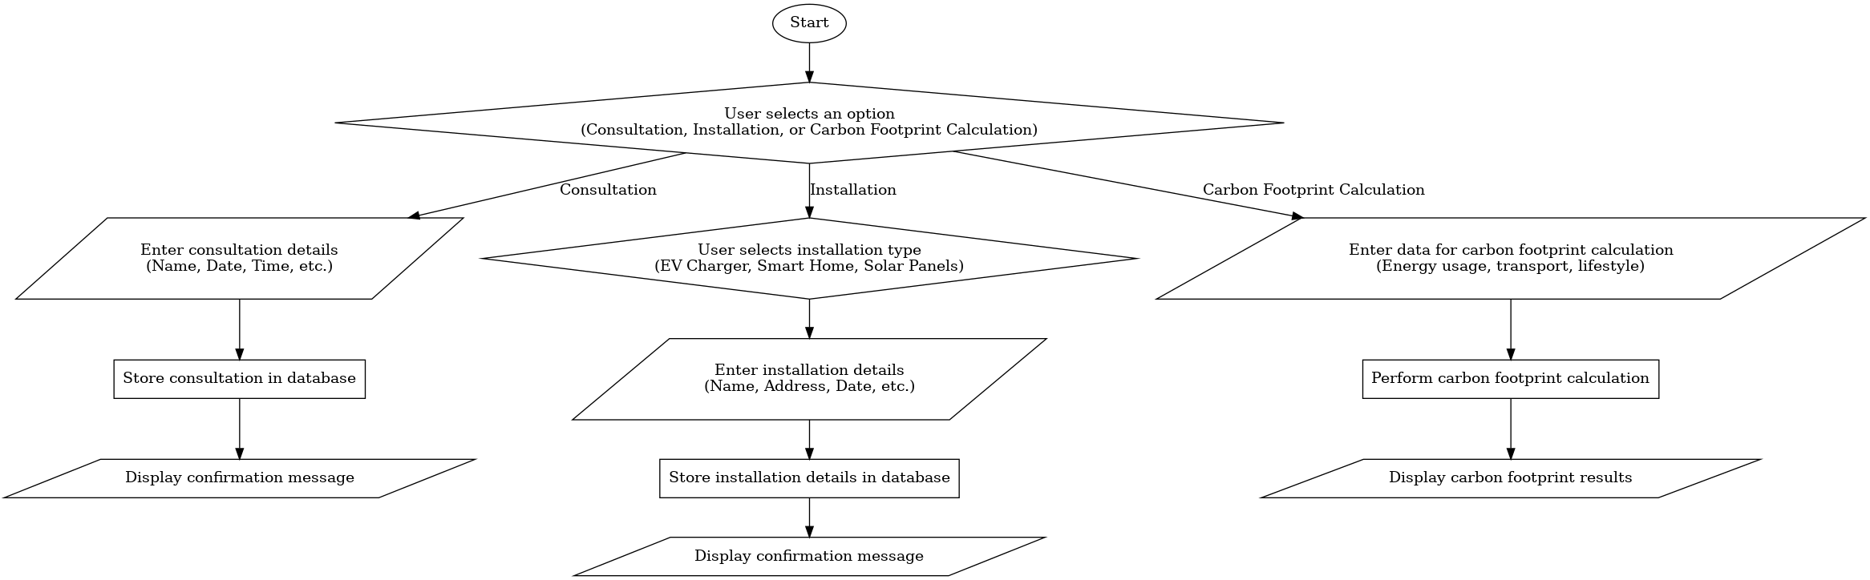

Paraphrase this!

For this project, manual testing will be utilized to thoroughly evaluate each component and its interactions. However, as the project evolves, incorporating automated testing may be considered to optimize testing processes and improve long-term scalability

|  |  |  |  |
| --- | --- | --- | --- |
| **Date of Test** | **Component to be Tested** | **Type of Test to be Carried Out** | **Prerequisites and Dependencies** |
| 2025-03-19 | Navigation Bar | Black Box Testing | None. Ensure all menu items are clickable and redirect correctly. |
| 2025-03-20 | Home Page | Functional Testing | Test the main page loads, content visibility, and interaction. |
| 2025-03-21 | About Us Page | Functional Testing | Ensure the page loads with the correct content. |
| 2025-03-22 | Energy Section | Black Box Testing | Verify that energy data is displayed correctly based on user input. |
| 2025-03-23 | Carbon Calculation Tool | Functional Testing, Unit Testing | Test the calculation algorithm, check for input validation, and ensure accuracy of results. |
| 2025-03-24 | Schedule Page (Booking) | Integration Testing, Functional Testing | Test booking functionality, ensuring data is saved correctly and the system updates availability. |
| 2025-03-25 | Login System (Frontend) | Black Box Testing, Functional Testing | Test login functionality with valid/invalid credentials and session management. |
| 2025-03-26 | Login System (Database) | Backend Database Testing, Integration Testing | Ensure database connections are established and stored user data is correct. |
| 2025-03-27 | Sign In Page | Black Box Testing, Functional Testing | Ensure sign-in process works with correct form validation and error handling for invalid credentials. |
| 2025-03-28 | Contact Form | Functional Testing | Test form submission, email sending, and error handling. |
| 2025-03-29 | Mobile Responsiveness | Black Box Testing | Ensure all pages work across multiple devices and screen sizes. |
| 2025-03-30 | API for Carbon Calculation | Unit Testing, Integration Testing | Test API endpoints for carbon calculation and integration with the front end. |
| 2025-03-31 | Footer Section | Black Box Testing | Verify that all footer links and information are correct and functional. |
| 2025-04-01 | User Dashboard | White Box Testing, Functional Testing | Test user-specific content display, navigation, and data retrieval from the database. |
| 2025-04-02 | Search Functionality | Integration Testing, Functional Testing | Test search queries and integration with database to return correct results. |
| 2025-04-03 | Notifications System | Integration Testing | Ensure notifications are sent based on user actions and stored in the database. |